WEEK – 3
Spring Core and Maven

1) Configuring a Basic Spring Application
*pom.xml :
<!-- Spring Core Dependency -->
<dependency>
<groupId>org.springframework</groupId>
<artifactId>spring-context</artifactId>
<version>5.3.34</version>
</dependency>

*applicationContext.xml :
<?xml version="1.0" encoding="UTF-8"?>
<beans xmlns="http://www.springframework.org/schema/beans"
xmlns:xsi="http://www.w3.org/2001/XMLSchema-instance"
xsi:schemaLocation="
http://www.springframework.org/schema/beans
http://www.springframework.org/schema/beans/spring-beans.xsd">
<!-- BookRepository Bean -->
<bean id="bookRepository" class="com.library.repository.BookRepository"/>

<!-- BookService Bean -->
<bean id="bookService" class="com.library.service.BookService">
<property name="bookRepository" ref="bookRepository"/>
</bean>
</beans>

*BookRepository.java :
package com.library.repository;
public class BookRepository {
public void displayBooks() {
System.out.println("BookRepository: Displaying book list...");
}
}

*BookService.java :
package com.library.service;
import com.library.repository.BookRepository;
public class BookService {
private BookRepository bookRepository;
// Setter for dependency injection
public void setBookRepository(BookRepository bookRepository) {
this.bookRepository = bookRepository;
}
public void showBooks() {
System.out.println("BookService: Calling repository...");
bookRepository.displayBooks();
}
}
*MainApp.java :
package com.library;
import org.springframework.context.ApplicationContext;
import org.springframework.context.support.ClassPathXmlApplicationContext;
import com.library.service.BookService;
public class MainApp {
public static void main(String[] args) {
ApplicationContext context = new ClassPathXmlApplicationContext("applicationContext.xml");
BookService bookService = context.getBean("bookService", BookService.class);
bookService.showBooks();
}
}
Output :
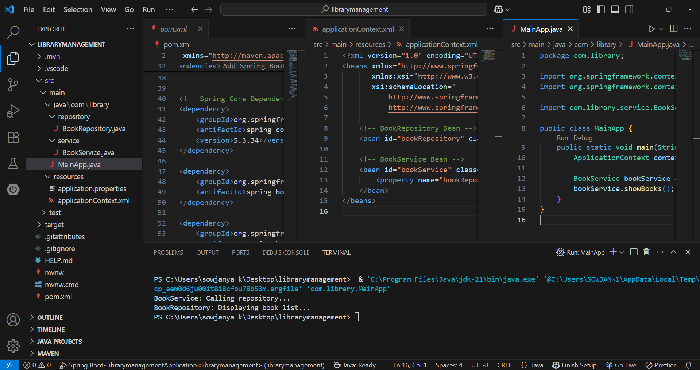
2) Implementing Dependency Injection
*applicationContext.xml :
<?xml version="1.0" encoding="UTF-8"?>
<beans xmlns="http://www.springframework.org/schema/beans"
xmlns:xsi="http://www.w3.org/2001/XMLSchema-instance"
xsi:schemaLocation="
http://www.springframework.org/schema/beans
http://www.springframework.org/schema/beans/spring-beans.xsd">
<!-- BookRepository Bean -->
<bean id="bookRepository" class="com.library.repository.BookRepository"/>

<!-- BookService Bean -->
<bean id="bookService" class="com.library.service.BookService">
<property name="bookRepository" ref="bookRepository"/>
</bean>
</beans>

*BookRepository.java :
package com.library.repository;
public class BookRepository {
public void displayBooks() {
System.out.println("BookRepository: Displaying book list...");
}
}
*BookService.java :
package com.library.service;
import com.library.repository.BookRepository;
public class BookService {
private BookRepository bookRepository;
// Setter for dependency injection
public void setBookRepository(BookRepository bookRepository) {
this.bookRepository = bookRepository;
}
public void showBooks() {
System.out.println("BookService: Calling repository...");
bookRepository.displayBooks();
}
}

*MainApp.java :
package com.library;
import org.springframework.context.ApplicationContext;
import org.springframework.context.support.ClassPathXmlApplicationContext;
import com.library.service.BookService;
public class MainApp {
public static void main(String[] args) {
ApplicationContext context = new ClassPathXmlApplicationContext("applicationContext.xml");
BookService bookService = context.getBean("bookService", BookService.class);
bookService.showBooks();
}
}

Output :

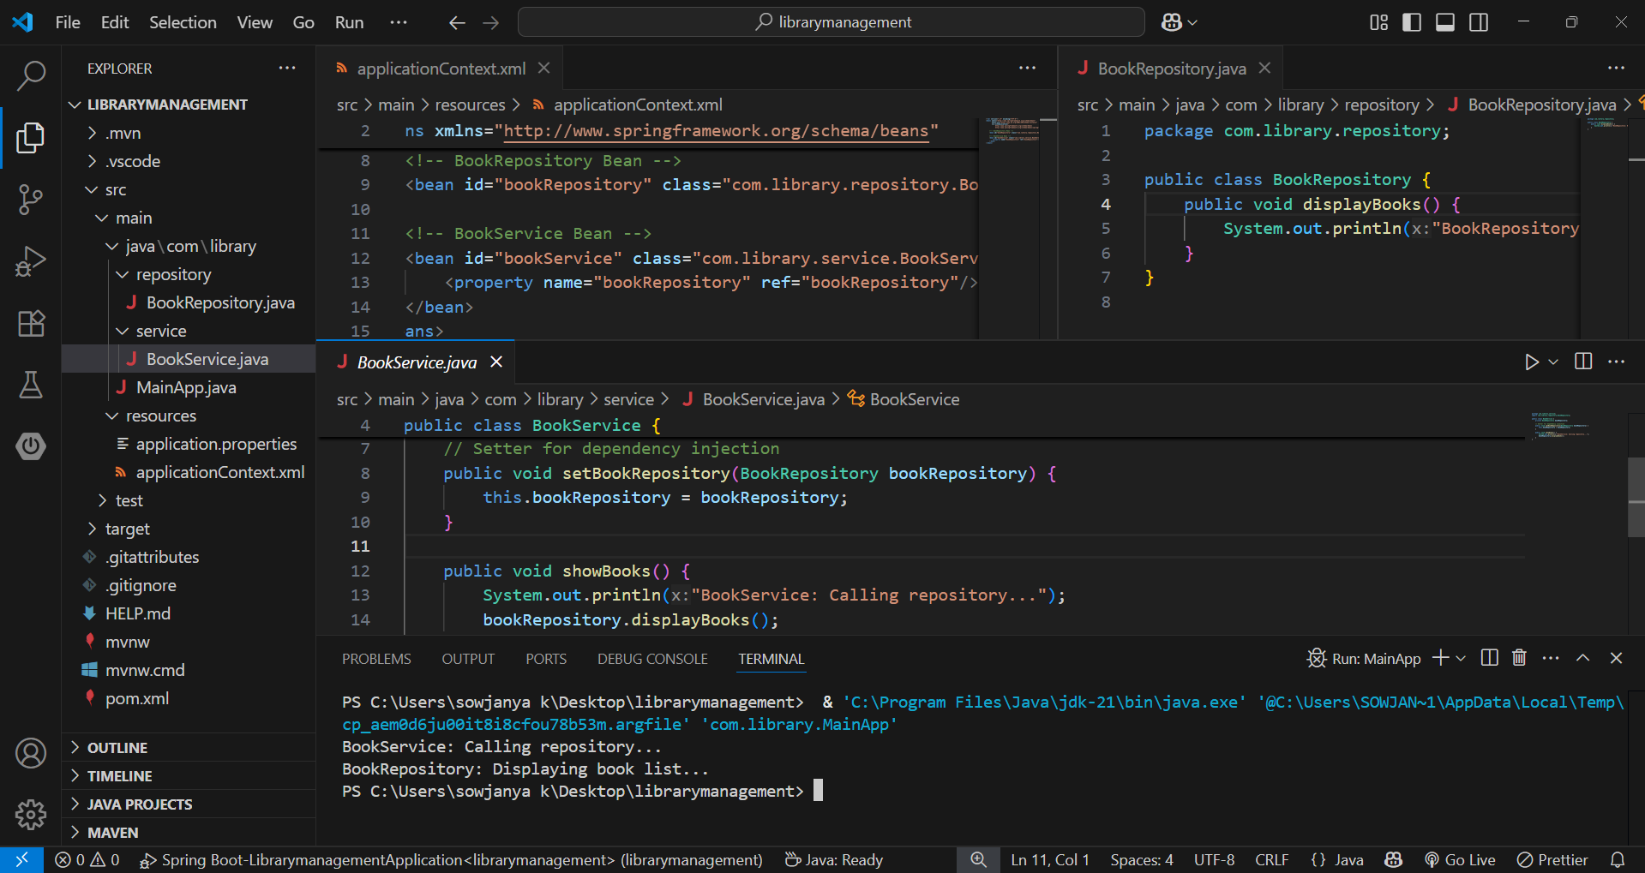

- The output shows that Spring’s IoC container successfully manages the dependency between BookService and BookRepository using setter-based Dependency Injection.
- The <property> element in applicationContext.xml wires BookRepository into BookService, and the setter method setBookRepository() ensures the injection works correctly when running the MainApp class.

3) Creating and Configuring a Maven Project
*pom.xml :
<project xmlns="http://maven.apache.org/POM/4.0.0"
xmlns:xsi="http://www.w3.org/2001/XMLSchema-instance"
xsi:schemaLocation="
http://maven.apache.org/POM/4.0.0
http://maven.apache.org/xsd/maven-4.0.0.xsd">

<modelVersion>4.0.0</modelVersion>
<groupId>com.library</groupId>
<artifactId>LibraryManagement</artifactId>
<version>1.0-SNAPSHOT</version>

<dependencies>
<!-- Spring Context -->
<dependency>
<groupId>org.springframework</groupId>
<artifactId>spring-context</artifactId>
<version>5.3.34</version>
</dependency>

<!-- Spring AOP -->
<dependency>
<groupId>org.springframework</groupId>
<artifactId>spring-aop</artifactId>
<version>5.3.34</version>
</dependency>

<!-- Spring WebMVC -->
<dependency>
<groupId>org.springframework</groupId>
<artifactId>spring-webmvc</artifactId>
<version>5.3.34</version>
</dependency>
</dependencies>

<build>
<plugins>
<!-- Maven Compiler Plugin for Java 1.8 -->
<plugin>
<groupId>org.apache.maven.plugins</groupId>
<artifactId>maven-compiler-plugin</artifactId>
<version>3.8.1</version>
<configuration>
<source>1.8</source>
<target>1.8</target>
</configuration>
</plugin>
</plugins>
</build>
</project>

Output :

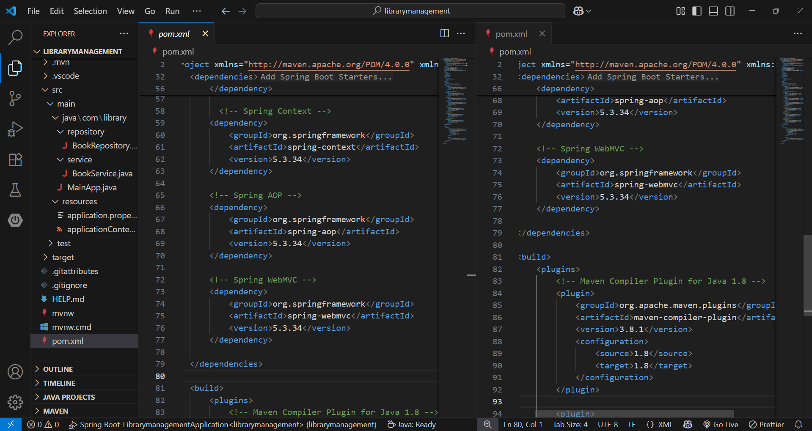

- The pom.xml is configured for the LibraryManagement project with Spring Context, Spring AOP, and Spring WebMVC dependencies.
- The Maven Compiler Plugin is set for Java version 1.8.

